Explainable AI and Model Interpretability for Student Engagement and Academic Outcome Prediction

1. Introduction
Artificial Intelligence systems are increasingly being used in education to analyze student behavior, predict academic performance, and identify students who may be at risk of poor outcomes or disengagement. While predictive accuracy is important, modern AI systems must also be transparent and explainable. In many real-world situations, stakeholders such as teachers, academic advisors, and administrators need to understand why an AI model makes a particular prediction before they can trust and act upon it.
The LearnPulse AI project was developed as an Early Warning System for Student Engagement and Academic Outcome Prediction. The project uses educational data from the Open University Learning Analytics Dataset (OULAD) to predict student outcomes based on engagement and academic performance indicators. During Week 1, project planning and problem analysis were completed. During Week 2, data preprocessing and feature engineering were performed. During Week 3, a Random Forest machine learning model was developed, trained, optimized, and evaluated.
Although the Week 3 model achieved useful predictive performance, it still behaved as a complex machine learning system whose internal decision-making process was not immediately understandable. Therefore, Week 4 focuses on Explainable Artificial Intelligence (XAI) techniques that help reveal how the model reaches its predictions.
The objective of this phase is to increase transparency, improve trustworthiness, and identify the most influential factors affecting student academic outcomes.

2. Project Background
The LearnPulse AI project aims to identify students who may require academic support before poor outcomes occur. Educational institutions often struggle to detect disengaged students early enough to provide meaningful interventions.
Traditional approaches rely heavily on manual observation and periodic assessments. However, educational datasets now contain rich information regarding student engagement, online learning activity, assessment performance, and demographic factors.
The OULAD dataset provides detailed information about student interactions within a Virtual Learning Environment (VLE). This makes it suitable for developing predictive models that can estimate academic outcomes and identify risk patterns.
The final target variable used in this project is the student's academic outcome, represented by categories such as:
- Withdrawn
- Fail
- Pass
- Distinction
By understanding the factors influencing these predictions, educational institutions can design targeted support strategies to improve student success.

3. Dataset Overview
The dataset used throughout the project is the Open University Learning Analytics Dataset (OULAD).
Several source tables were combined and processed:
- studentInfo
- studentVle
- studentAssessment
- studentRegistration
The original dataset contained over 32,000 student records and millions of learning activity records.

During Week 2, feature engineering was performed to create meaningful variables such as:
- assessment_count
- average_score
- total_clicks
- avg_clicks

Additional demographic and educational attributes were retained, including:
- code_module
- code_presentation
- region
- highest_education
- studied_credits
- imd_band
The final processed dataset contained:
32593 student records
15 feature columns
1 target column
These engineered features formed the basis of the predictive model used in Week 3 and analyzed during Week 4.

4. Machine Learning Model Used
The predictive model selected for this project was the Random Forest Classifier.
Random Forest was chosen because:
- It performs well on structured tabular datasets.
- It can handle both categorical and numerical variables.
- It is robust against overfitting.
- It naturally provides feature importance scores.
- It offers strong predictive performance without extensive feature scaling requirements.
The dataset was divided into:
80% Training Data
20% Testing Data
The model was initially trained using default parameters.
Subsequently, hyperparameter tuning was performed using GridSearchCV.
The following parameters were explored:

n_estimators:
50, 100, 200

max_depth:
5, 10, 20
The best parameter combination obtained was:
n_estimators = 200
max_depth = 20
These optimized parameters were used to train the final model analyzed in this report.

5. Model Performance Summary
The optimized Random Forest model achieved the following results:
Best Accuracy:
0.6864
Final Evaluation Accuracy:
0.6826
Classification performance showed that the model performed particularly well for the Pass and Distinction categories.
Summary metrics:
Accuracy: 68.26%

Macro Average Precision: 0.65
Macro Average Recall: 0.61
Macro Average F1 Score: 0.62
These results indicate that the model successfully captures meaningful patterns in student engagement and assessment behavior.

6. Explainable AI (XAI)
Explainable Artificial Intelligence refers to methods that make machine learning predictions understandable to humans.
Traditional machine learning models often act as "black boxes."
Input:
Student Features
Output:
Pass / Fail / Distinction
However, stakeholders may not know why the prediction was made.
Explainable AI addresses this problem by providing insight into:
- Which features influenced predictions
- The relative importance of variables
- The relationship between inputs and outcomes
- Model behavior and reasoning
In educational environments, explainability is especially important because decisions can directly affect student support strategies.

Identifies and Mitigates Algorithmic Bias: XAI exposes whether a model is relying on unfair or discriminatory factors (like demographic data, socio-economic status, or gender) to predict student success, allowing institutions to correct the model and ensure equitable student support.

Fosters Trust among Educators and Students: When a model acts as a "black box," teachers and administrators are hesitant to rely on its predictions. Providing clear reasoning builds the necessary trust for stakeholders to confidently adopt AI recommendations in their daily workflows.

Enables Early and Targeted Pedagogical Interventions: Instead of just flagging a student as "at risk of failing," explainable models pinpoint the exact reason—such as sudden drops in forum participation or low quiz scores—allowing educators to design precise, personalized learning interventions before it is too late.
7. Feature Importance Analysis
Feature Importance Analysis was selected as the primary Explainable AI technique.
Random Forest models calculate the contribution of each feature during the decision-making process.
The feature importance results obtained were:
Feature | Importance
assessment_count | 0.199
average_score | 0.182
total_clicks | 0.131
avg_clicks | 0.102
id_student | 0.086
region | 0.054
code_module | 0.053
imd_band | 0.050
studied_credits | 0.036
code_presentation | 0.034

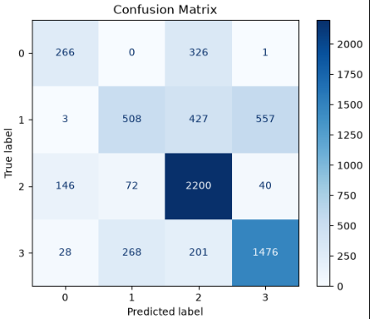
Caption: Figure 1. Feature Importance Analysis generated from the Random Forest model.
The results reveal that assessment-related features dominate prediction performance.
The most influential variable was:
assessment_count
This indicates that students who actively complete assessments tend to achieve better academic outcomes.
The second most important feature was:
average_score
This demonstrates that assessment quality is nearly as important as assessment participation.
Engagement-related variables such as:
total_clicks
avg_clicks
also contributed significantly.
These findings align with educational theory, which suggests that active participation and consistent engagement strongly influence academic success.

8. Permutation Importance Analysis
Although Random Forest provides built-in feature importance scores, additional validation is beneficial.
Therefore, Permutation Importance Analysis was performed.
This method works by randomly shuffling one feature at a time and measuring how much model performance decreases.
If accuracy decreases substantially, the feature is considered important.
If accuracy remains unchanged, the feature contributes little to the prediction process.
Permutation Importance offers a model-agnostic way to verify feature significance.
The results confirmed the importance of:
- assessment_count
- average_score
- total_clicks
- avg_clicks
These variables consistently caused the largest performance drops when shuffled.
This validates the conclusions obtained from the Feature Importance Analysis.

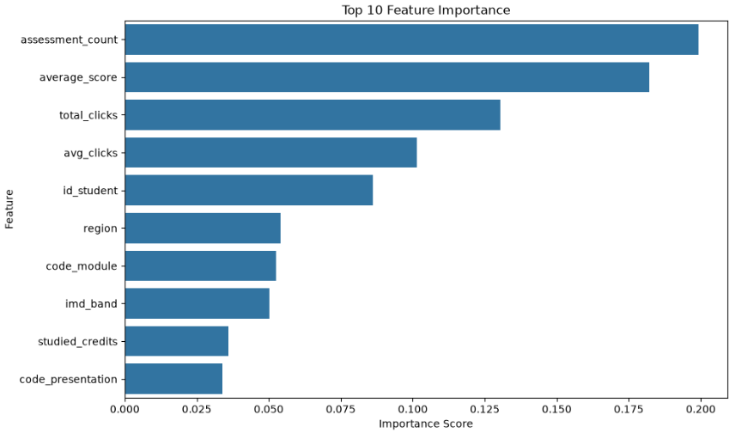Caption: Figure 2. Permutation Importance Analysis validating the influence of major features.

The consistency between both methods increases confidence in the reliability of the model explanations.

9. Confusion Matrix Analysis
A confusion matrix was generated to analyze prediction behavior across different academic outcome categories.
The matrix provides detailed insight into:
- Correct classifications
- Misclassifications
- Class-level prediction patterns

The results showed that:
- Pass predictions achieved strong performance.
- Distinction predictions were identified effectively.
- Withdrawn and Fail categories remained more difficult to classify.
This outcome is expected because student behavior patterns in these categories often overlap.
For example:
A student with moderate engagement could either:
Fail
or
Withdraw
depending on additional factors not fully represented in the dataset.

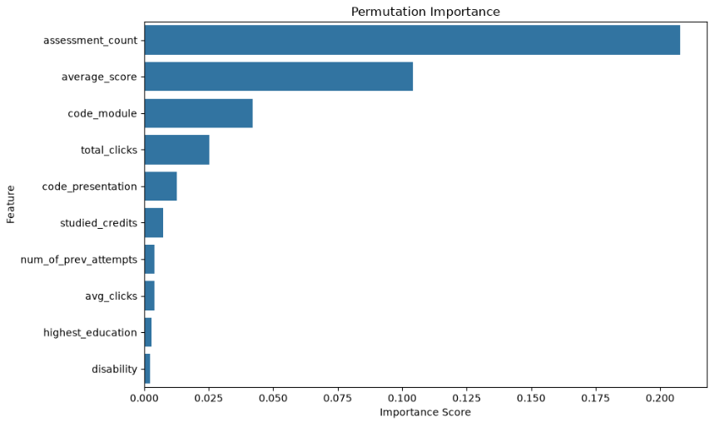Caption: Figure 3. Confusion Matrix showing classification performance across academic outcome categories.

The confusion matrix provides a valuable visual representation of model strengths and limitations.

10. Interpretation of Findings
The Explainable AI analysis provides several important insights.
First, assessment participation emerged as the strongest predictor of student success.
Students who completed more assessments generally achieved better outcomes.
Second, average assessment performance was highly influential.
Students with consistently strong scores demonstrated a higher probability of passing or obtaining distinctions.
Third, engagement metrics such as:
- total_clicks
- avg_clicks
played a significant role.
This suggests that active interaction with learning materials is associated with improved academic performance.
Finally, demographic variables contributed to prediction performance but had lower influence than academic and engagement-related factors.
This indicates that student behavior and effort have a stronger impact on outcomes than demographic characteristics.

11. Real-World Applications
The findings from this project have several practical applications.
Educational institutions can use similar systems to:
Early Risk Detection
Identify students showing signs of disengagement before academic failure occurs.
Personalized Support
Provide targeted interventions based on engagement patterns.
Resource Allocation
Direct academic support services toward students with higher risk profiles.
Student Monitoring
Track engagement trends throughout a course.
Academic Planning
Help instructors understand which activities contribute most strongly to student success.
These applications demonstrate the value of Explainable AI in educational decision-making.

12. Challenges Encountered
Several challenges were encountered during this phase.
Large Dataset Size
The OULAD dataset contains millions of engagement records, requiring extensive preprocessing.
Feature Engineering Complexity
Transforming raw engagement logs into meaningful indicators required careful design.
Class Imbalance
Some academic outcome categories contained fewer observations than others.
Interpretability vs Complexity
Complex models often achieve higher accuracy but are harder to explain.
Balancing predictive performance and explainability required selecting suitable interpretation methods.
Technical Environment Issues
During implementation, library compatibility and system security restrictions affected some advanced Explainable AI tools. Alternative interpretability techniques were therefore used to ensure successful completion of the analysis.

13. Limitations
Although the project achieved promising results, several limitations remain.
- The dataset originates from a specific educational context.
- Additional behavioral variables could improve prediction accuracy.
- Explainability methods provide approximations rather than complete representations of model reasoning.
- Predictions should support human decision-making rather than replace it.
Future work may involve:
- SHAP analysis
- LIME explanations
- Deep learning models
- Real-time student monitoring systems

14. Conclusion
This report presented the Explainable AI phase of the LearnPulse AI project. Building upon the planning, preprocessing, and model development completed in earlier weeks, this stage focused on understanding how the Random Forest model makes predictions regarding student academic outcomes.
Feature Importance Analysis and Permutation Importance Analysis were successfully implemented to identify the most influential variables affecting predictions. The results consistently demonstrated that assessment participation, average assessment scores, and student engagement metrics are the strongest predictors of academic success.
The model achieved an accuracy of approximately 68%, while the explainability techniques provided meaningful insights into the decision-making process. Visualizations such as feature importance charts, permutation importance graphs, and confusion matrices enhanced the interpretability of the results and supported transparent analysis.
Overall, Week 4 successfully transformed the predictive model from a black-box system into a more understandable and trustworthy educational AI solution. The findings demonstrate the importance of Explainable AI in educational analytics and highlight the potential of machine learning systems to support proactive student success initiatives when used responsibly and transparently.

